2-a1 For First Order Upwind:
For dissipation, one can set a=1, since we can re-scale x and t to achieve that. That means V_{ph} is only related to h_{t} and h_{x}.
We first set h_{t}=0.01 to see what’s going on if CFL is satisfied. As h_{x} goes to h_{t}, |s(k)|goes to 1. (Figure 2-a1-1). This is true since S(k)=exp(-ikh_{x}) when λ=1.
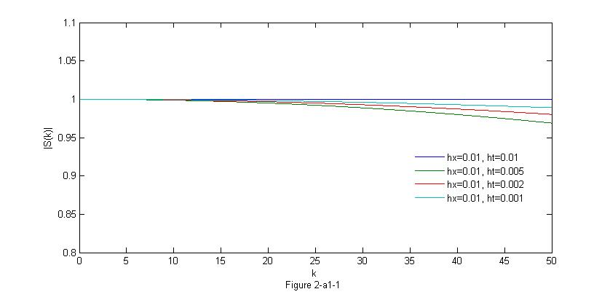
We first set h_{t}=0.01 to see what’s going on if CFL is not satisfied. As h_{x} goes bigger, |s(k)| blows up. (Figure 2-a1-2). This will bring unstability. (L=30.)
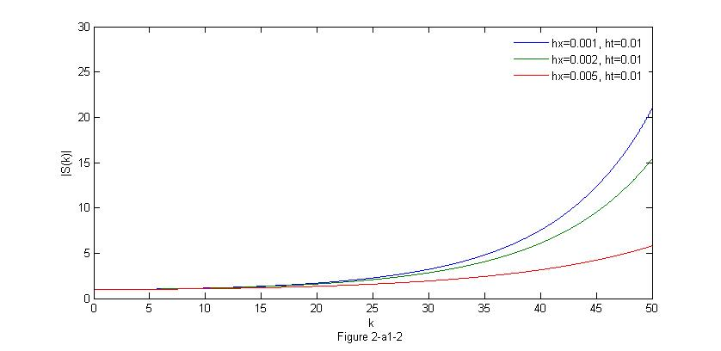
For dispersion, if λ→1 or λ→0, V_{ph}→1. And λ→1 has a bigger effect in eliminating dispersion.
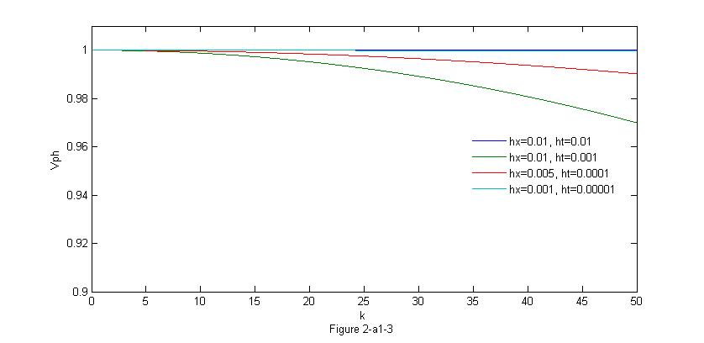
2-a2 For Crank-Nicholson:
For dissipation, |s(k)|=1. So there is no dissipation in C-N. (Figure 2-a2-1)
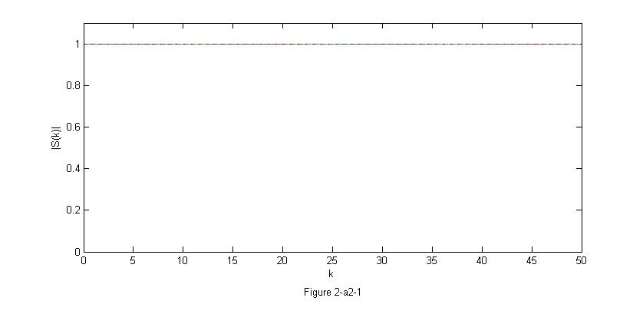
For dispersion, again one can set a=1, since we can re-scale x and t to achieve that. That means V_{ph} is only related to h_{t} and h_{x}.

We first set h_{t}=0.01 to see what’s going on. As h_{x} goes to 0, V_{ph} goes to 1. (Figure 2-a2-2)
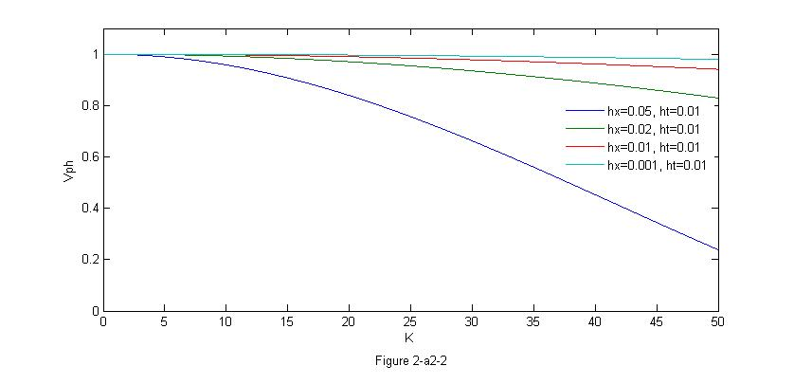

We than set h_{x}=0.01 to see what’s going on. As h_{t} goes to 0, V_{ph} goes to 1. (Figure 2-a2-3)
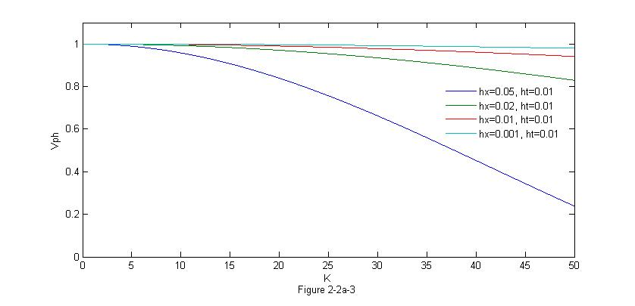
Finally, we set λ=0.25(h_{t}=h_{x}) to see what’s going on. As h_{x} goes to 0, V_{ph} goes to 1. (Figure 2-a2-4)
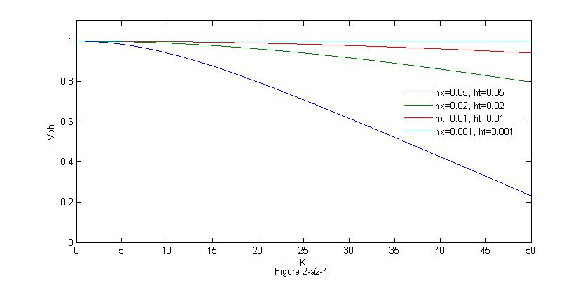
Our conclusion here is for C-N, the dispersion always exists. To control it, we can try to make both h_{x} and h_{t} smaller. However, for functions decomposed into Fourier series with distinct small K_{m} and large K_{n}(i.e K_{n}→∞), we cannot avoid dispersion.
2-b Observation of Dissipation and Dispersion
 | Dissipation | Dispersion
1st Upwind CFL λ=1 | 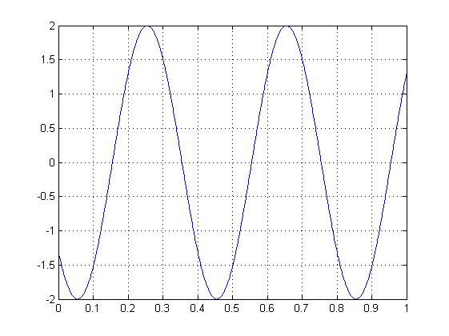  2Cos(5πx)  No dissipation | 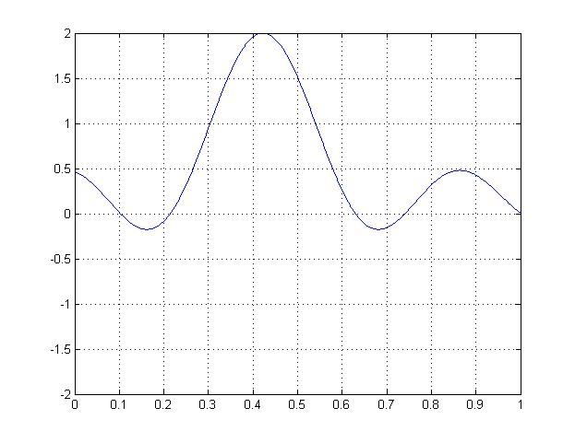  0.5(cos(15x)+cos(x)+cos(5x)+cos(10x))  No Dispersion
1st Upwind CFL λ=0.5 | 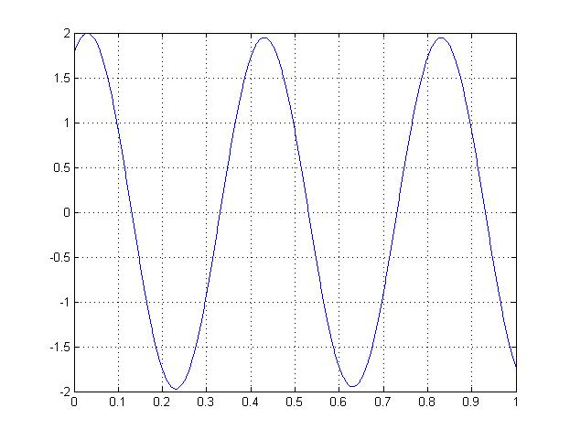  2Cos(5πx)  Dissipation: The max is smaller than 2 on the right. | 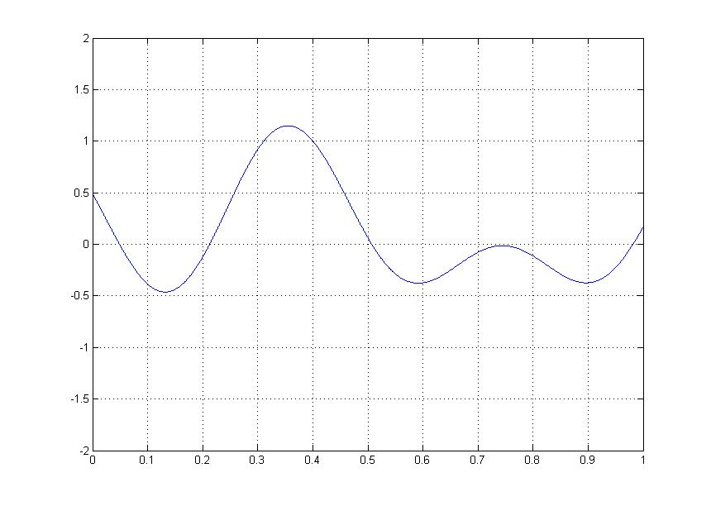  0.5(cos(5πx)+cos(0.5πx)-cos(πx)-cos(3πx));  Dispersion: Small Wiggles Observed
1st Upwind non-CFL  λ=10 | Unstable  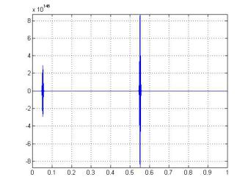  2Cos(5πx) | Unstable  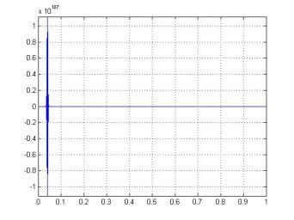  0.5(cos(15x)+cos(x)+cos(5x)+cos(10x))
Crank-Nicholson | 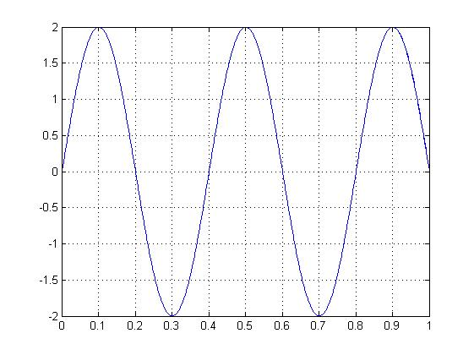  2Cos(5πx)  No dissipation | 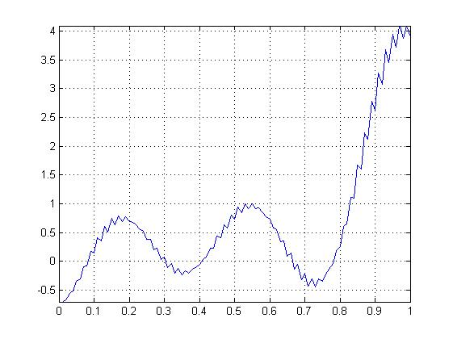  0.5(cos(15x)+cos(x)+cos(5x)+cos(10x))  Dispersion

